**Secure E-commerce Blockchain Payment System**

**Overview:**

The goal of this project proposal is to design and build an online store that will use blockchain technology to process payments securely and quickly. The website will offer a platform for companies and customers to conduct transactions easily without the need for middlemen or intermediaries, enhancing the payment process's transparency and reliability.

**Background:**

Online businesses are focusing more on the payment process as e-commerce grows in popularity. The difficulties online businesses have processing payments can be overcome by using blockchain technology, which offers secure, transparent, and quick payment processing without the use of middlemen. Additionally, blockchain technology offers unchangeable records of transactions, enhancing payment process transparency and trust.

**Objectives:**

The proposed project for an e-commerce website has four different goals. The first objective is to create a user-friendly online store with an intuitive user interface and a quick payment processing system. This will facilitate customer transactions on the website and improve the overall customer experience.

In order to ensure secure, open, and quick transactions in the payment processing system, the project also aims to implement blockchain technology. Blockchain technology will improve the security and effectiveness of the payment processing system, giving users a more dependable and trustworthy platform to conduct transactions.

Third, customers will be able to pay for goods and services using cryptocurrencies like Bitcoin, Ethereum, and Litecoin. Customers who prefer to use cryptocurrencies for their online purchases will benefit from more flexibility as a result.

By utilizing blockchain technology and providing cryptocurrency payment options, the project's overall goals are focused on enhancing the customer experience and the security, quickness, and efficiency of the payment processing system.

**The goal of the Work:**

The following tasks will be included in the project:

• Creating and designing an e-commerce website with a user-friendly user interface and smooth payment processing.

• Developing smart contracts as part of the integration of blockchain technology into the payment processing infrastructure.

• The creation of a cryptocurrency payment gateway that will enable companies to accept cryptocurrency payments and exchange them for fiat money.

**Scope of Work:**

The project will involve the following tasks:

* Design and development of the e-commerce website with an intuitive interface and seamless payment processing.
* Integrating blockchain technology into the payment processing system, including developing smart contracts.
* Development of a cryptocurrency payment gateway to allow businesses to accept cryptocurrencies as payment and convert them into fiat currencies.
* Implementation of security measures to protect the website and payment processing system from potential attacks.
* Development of a user manual to guide customers and businesses on how to use the website and payment processing system.
* The implementation of security measures to guard against potential attacks on the website and the payment processing system.

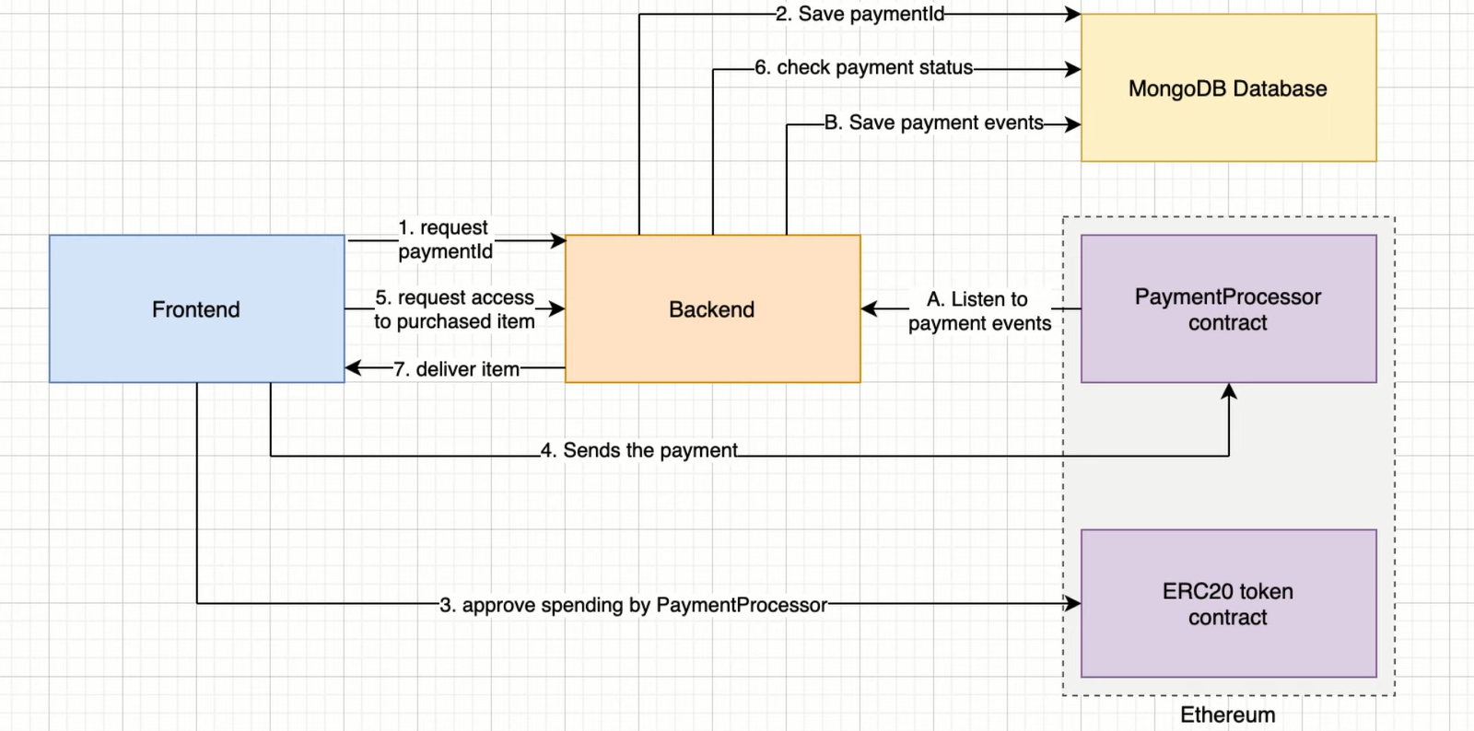

**Deliverables:**

The project's deliverables include the following:

• An e-commerce website that is fully functional and has a user-friendly interface and smooth payment processing.

• A payment processing system incorporating blockchain technology for safe, quick, and transparent transactions.

• A cryptocurrency payment gateway that enables companies to take payments in cryptocurrencies and exchange them for fiat money.

• Security measures are put in place to guard against potential attacks on the website and the system for processing payments.

**Blockchain Payment System:**

Smart contracts must be developed in order to incorporate blockchain technology into the payment processing system. In smart contracts, the terms of the agreement between the buyer and seller are directly written into lines of code. These contracts self-execute. They are immutable, which means that they cannot be changed once they are deployed, and they operate on a decentralized blockchain network.

For the payment processing system, we will develop a unique smart contract that will guarantee the safe and open execution of every transaction. After confirming that the buyer has enough money to finish the deal, the smart contract will automatically transfer the money to the seller.

**Cryptocurrency Payment Gateway:**

Business organizations will be able to accept cryptocurrencies as payment thanks to the cryptocurrency payment gateway. Businesses will be able to accept payments in a variety of cryptocurrencies thanks to the gateway's integration with different cryptocurrency exchanges.

**Security Measures:**

To guard against potential attacks on the website and payment processing system, we will place several security measures. These safeguards will use two-factor authentication for user accounts, SSL encryption for secure data transfer, and recurring security reviews and updates.

In conclusion, if this project is completed successfully, businesses will have access to a secure, open, and effective payment processing system that can enhance customer satisfaction and give them a competitive edge. We are sure that our knowledge of blockchain technology and web development will enable us to deliver a solution that satisfies all the criteria listed in this proposal. Please feel free to get in touch with us if you have any additional questions or would like to go over the project in more detail.